4 - Object-Oriented Programming (OOP) Concepts
Object-Oriented Programming (OOP) is a programming paradigm that uses objects and classes to design and develop applications. The main concepts of OOP are classes, objects, inheritance, polymorphism, encapsulation, and abstraction. Here, we will focus on classes and objects.

1. Classes and Objects

Classes
A class is a blueprint for creating objects. It defines the properties (fields) and behaviors (methods) that the objects created from the class will have. A class encapsulates data for the object.
Syntax:
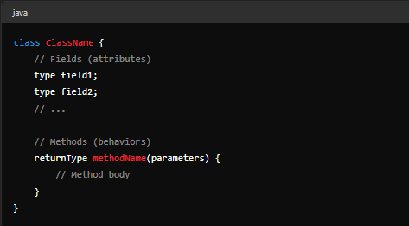
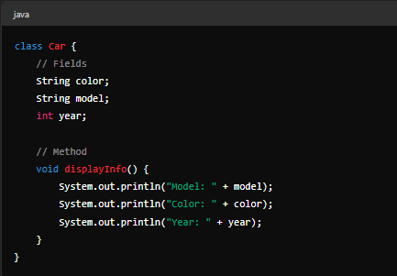
Example:

Objects
An object is an instance of a class. When a class is defined, no memory is allocated until an object of that class is created.
Creating an Object:

Example:
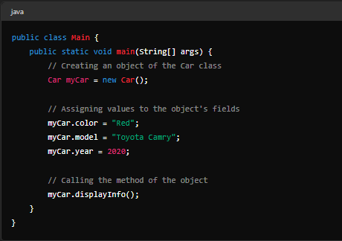
Output:
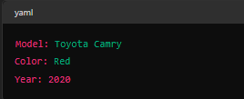

Example 2: Student Class
Class Definition:
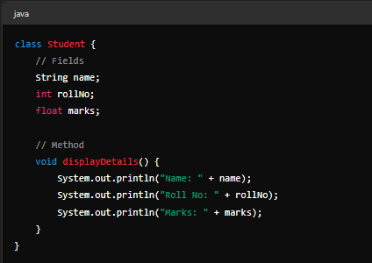
Main Program:
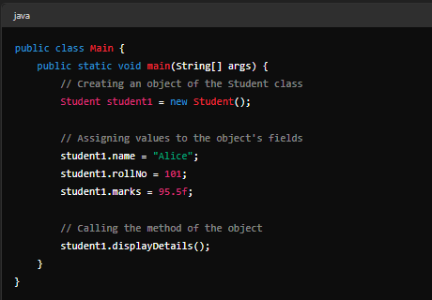

Output :

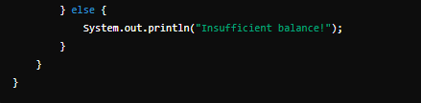
Example 3: BankAccount Class
Class Definition:
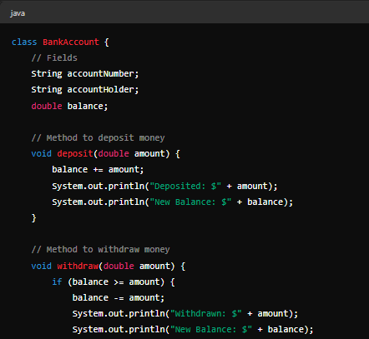
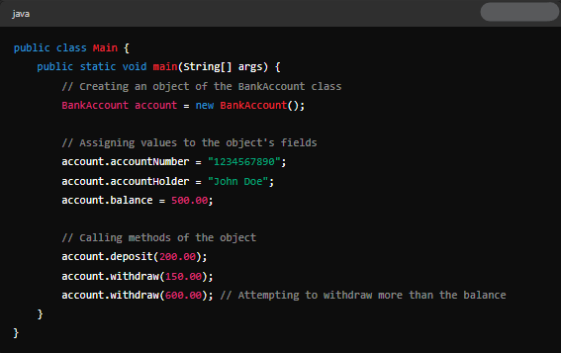
Main Program:
Output:


